Modern Data Ecosystem and the Role of Data Analytics

**Different Types of Data Analysis**

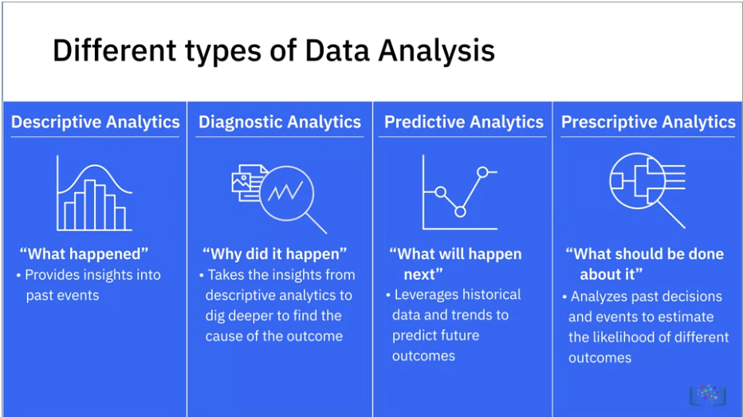

**Difference of Data Analytics & Data Engineering**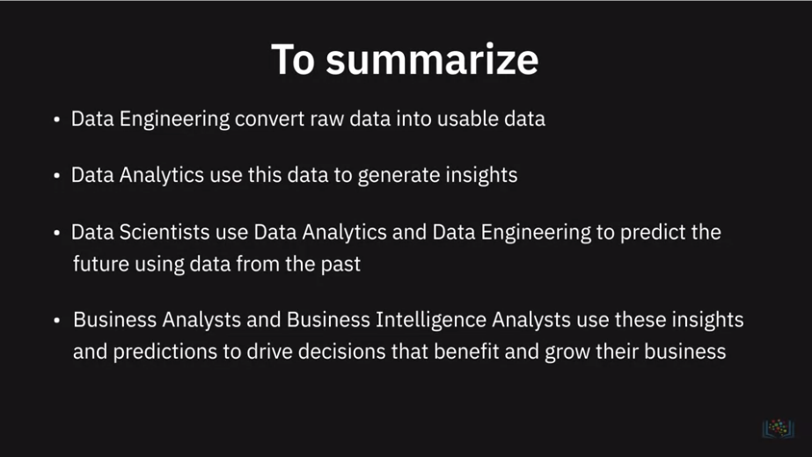

**Data Analytics vs. Data Analysis**

The terms **Data Analysis** and **Data Analytics** are often used interchangeably, including in this course.

However it is important to note that there is a subtle difference between the terms and meaning of the words *Analysis* and *Analytics*. In fact some people go far as saying that these terms mean different things and should not be used interchangeably. Yes, there is a technical difference...

The dictionary meanings are:

Analysis - *detailed examination of the elements or structure of something*

Analytics - *the systematic computational analysis of data or statistics*

*Analysis* can be done without numbers or data, such as business analysis psycho analysis, etc. Whereas *Analytics*, even when used without the prefix "Data", almost invariably implies use of data for perfoming numerical manipulation and inference.

Some experts even say that *Data Analysis* is based on inferences based on historical data whereas *Data Analytics* is for predicting future performance. The design team of this course does not subscribe to this view, and you will see why later in the course as you become familiar with the terms like *predictive analytics, prescriptive analytics, etc*.

So in this course we take a more liberal view, and use the terms Data Analysis and Data Analytics to mean the same thing. For example, an earlier video is titled *Defining Data Analysis*, whereas the preceeding video with the viewpoints of several data professionals is titled *What is Data Analytics*. The difference in these titles is not intentional.

# Summary and Highlights

In this lesson, you have learned the following information:

A modern data ecosystem includes a network of interconnected and continually evolving entities that include:

* Data that is available in a host of different formats, structure, and sources.
* Enterprise Data Environment in which raw data is staged so it can be organized, cleaned, and optimized for use by end-users.
* End-users such as business stakeholders, analysts, and programmers who consume data for various purposes.

Emerging technologies such as Cloud Computing, Machine Learning, and Big Data, are continually reshaping the data ecosystem and the possibilities it offers. Data Engineers, Data Analysts, Data Scientists, Business Analysts, and Business Intelligence Analysts, all play a vital role in the ecosystem for deriving insights and business results from data.

Based on the goals and outcomes that need to be achieved, there are four primary types of Data Analysis:

* Descriptive Analytics, that helps decode “What happened.”
* Diagnostic Analytics, that helps us understand “Why it happened.”
* Predictive Analytics, that analyzes historical data and trends to suggest “What will happen next.”
* Prescriptive Analytics, that prescribes “What should be done next.”

The Data Analysis process involves:

* Developing an understanding of the problem and the desired outcome.
* Setting a clear metric for evaluating outcomes.
* Gathering, cleaning, analyzing, and mining data to interpret results.
* Communicating the findings in ways that impact decision-making.